Dr. Surendra Kumar
John Robinson’s Model of economic Growth
Introduction:
Joan Robinson’s growth model clearly incorporates the problem of population growth in a developing economy and analyses the effects of population on the rate of capital accumulation and growth of output.
Mrs. Joan Robinson’s model of economic growth is based on two basic conditions, i.e:
(i) Capital formation depends upon the manner of distribution of income, and
(ii) The rate at which the labour is used depends upon the supply of capital and that of labour. Her model is given in her book ‘The Accumulation of Capital’ based on the capitalist rules of the game.

Assumptions:
She makes the following assumptions:
(a) Total income in real terms is divided between two classes—workers and entrepreneurs.
(b) Workers spend all their wages on consumption and save nothing.
(c) Profit seekers save and invest all their profits and consume nothing. If they have no profits, they cannot accumulate and if they don’t accumulate, they have no profits.
(d) That capital and labour are combined in fixed proportions to produce a given output (this assumption was dropped later on) i.e., there is no technological change. In other words, there is a given technique of production within fixed proportion of capital to labour.
(e) Her entire argument runs in ex-post terms. There is no change in the price level.
(f) There is a laissez-faire closed economy.
(g) There is no shortage of labour, the entrepreneur can find as much labour as they wish to enlarge the path of steady growth which in the Robinson framework is seen as a constant rate of capital accumulation, necessitates a rate of profit that leads businessmen to perpetuate the past rate of accumulation such a profit rate needs, for example, the condition that there be no surplus or scarcity of labour, that is, the labour force should grow at the same rate as capital.

Features:
Mrs. Robinson’s model is a dynamic two sector model in which she examines what happens in the quasi-long period. Her main thesis is that of the two classes in the basic model, workers consume everything they get; while businessmen reinvest whole of their profits, as a result a fundamental identity follows ; ex-post investment equals ex-post profits. However, there is a limit to entrepreneurs attempt to invest all their profits—this limit is set by the minimum level of real wages on which the workers insist.
Within that limit—inflation barrier—there are other barriers set by financial monetary factors, productive capacity, balance of payments, etc. At each step of the growth of the economy, these barriers are pushed up higher and higher and within these constraints growth depends upon the energy of the entrepreneurs.
The process of growth is eased and barriers are overcome if there is smooth flow of innovations. The ultimate stage is the ‘Golden Age’ and the potential growth ratio of the Golden Age economy is akin to Harrod’s natural rate of growth G_{n}. Thus, she is interested in explaining the fundamental nature of economic growth according to the ‘capitalist rules of the game’? For this purpose she builds a verbal model and K.K. Kurihara built up a real model, which is given hereafter.
The distribution equation which is most significant in her growth model is shown as under.
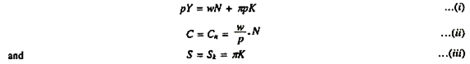
Here C_{n} is workers consumption out of wage income (w/p.N) and SK saving out of profit income (K). In equation (i) above net investment means an increase in real capital (AK), therefore, we have
I= ∆K ……………………(iv)
Considering equations (iii) and (iv) above, we can rewrite S and I relation as:
∆K = πK ……………….(v)
Because (S = I). Therefore = ∆K /K =π or ∆ K /K = πK/K but from equation (iii) above, we know
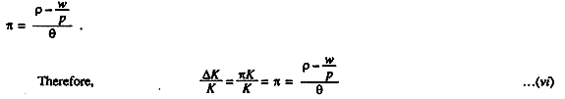
Thus, the rate of growth of capital given by equation (vi) is the rate which is attainable by entrepreneurs by following the capitalist rules of the game, according to J. Robinson. This equation shows that the rate of growth of capital is capable of increasing, if the net return of capital (P-w/P) rise in greater proportion than the capital-labour ratio. In Ricardian terms it means that capital accumulation is strengthened by a fall in the real wage rate. It appears that she has brought us back to Ricardo’s theory of economic development, though via Keynesian door.
Coming to Mrs. Robinson’s notion of ‘Golden Age’ i.e., equilibrium with full employment of labour and full utilization of capital. This is possible, if we assume (K/N) = θ = constant in conditions of full employment and full utilization; an increase in the amount of fully employed labour is given by ∆N = ∆K/θ ( K/N = θ).
From this relation we can have the rate of growth of fully employed labour:
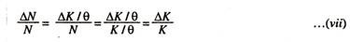
which shows that fully employed labour grows at the same rate as the rate of growth of capital, and which implies that capital must grow as fast as labour population, when capital-labour ratio (θ) remains constant. In other words, it shows that the rate of change in labour force (∆N/N) is equal to the rate of change in capital stock (∆K/K). Thus, given the perfect supply of labour, with respect to output, this equation signifies a golden age equilibrium with full employment of both labour and capital.
This is shown in Fig. 44.4, where Y is the net national income, N the amount of labour employed, K the amount of capital equipment utilized, p the average price of output as well as of capital equipment, w the money wage rate, and n the gross profits rate (including the interest rate) required for the normal utilization of the existing stock of real capital. Divide both sides of equation (i) above by p (the average price), we get the distribution equation in real terms:
Y = W/P N+ πK ,..(viii)
We want to find out the rate of profit shown as n in the equation so as to reach an equilibrium condition from demand side of the economy.
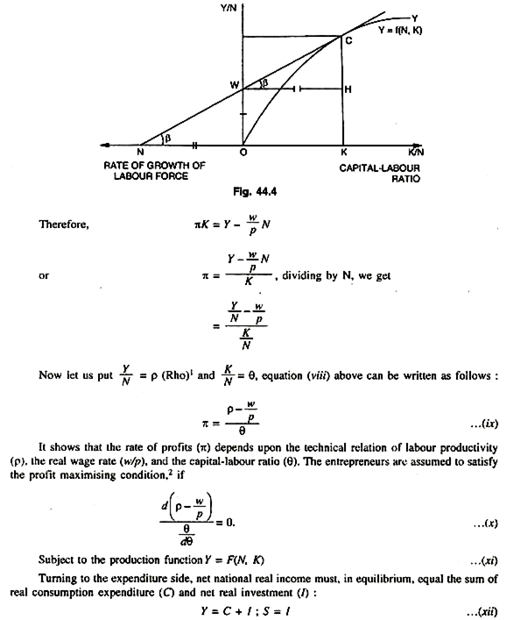
In this figure horizontal axis measures capital-labour ratio (K/N) in quadrant I. Vertical axis measures the labour income ratio or labour productivity (Y/N). OW is the minimum wage rate. In quadrant II, ON measures the rate of growth of labour force. OY shows the expansion path. A tangent is drawn touching at C. Now the rate of growth of capital = ∆I/I =Output- Input/ Input = Surplus/Input = HC/OW x OK =HC/WH x 1/OW (because tan β = tan β), therefore, HC /OK =HC/WH OK = WH = ON and OW = HC . Therefore, HC/WH 1/OW= OW/ ON x 1 /OW = 1/ON = the rate of growth of labour force. In other words, the rate of growth of surplus which is HC must be able to absorb the rate of growth of labour force which is ON here. This brings up to the ‘Golden Age’ according to Mrs. Joan Robinson.

